Manual

Colour Spectrum Exposure Unit

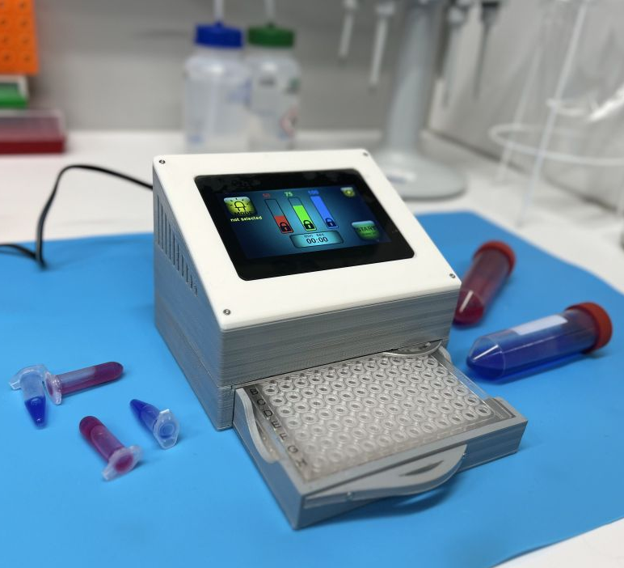

General description of function
The Colour Spectrum Exposure Unit is a device, which has been designed to enable the exposure of individually selected wells of a 96well plate with a defined spectrum of light.
A suitable bandpass filter is required. It needs to be inserted between 96well plate and light source.
A 440 nm bandpass filter is delivered with the device.
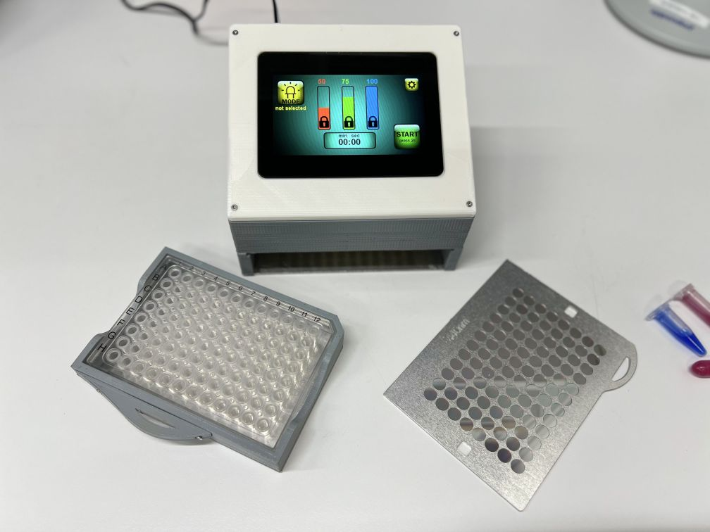
Filter
96 well plate

General overview of how to operate the display
Click or hold for 2 seconds to enter selections and settings, and start exposure.

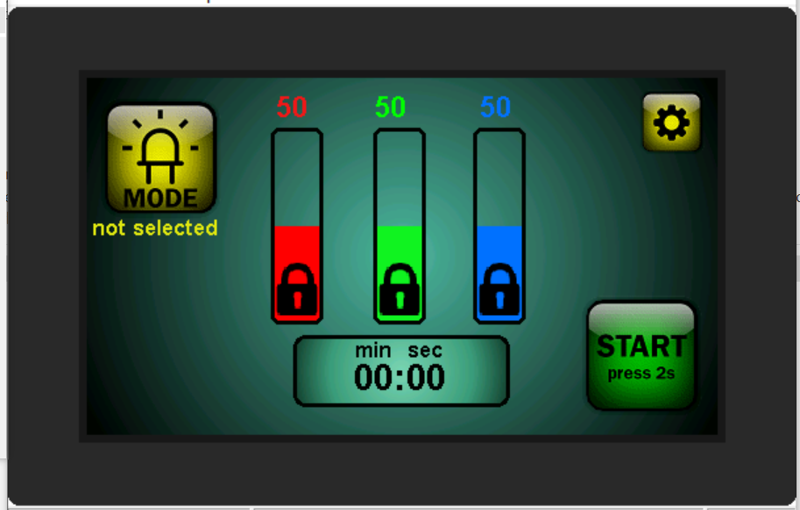
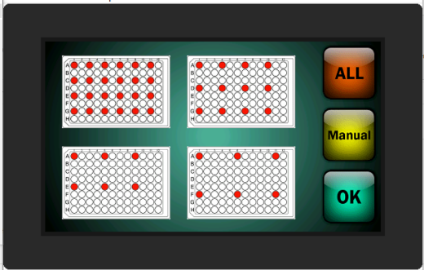
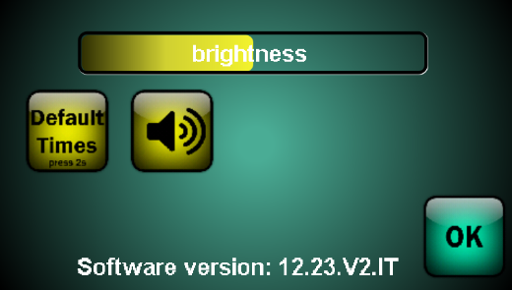
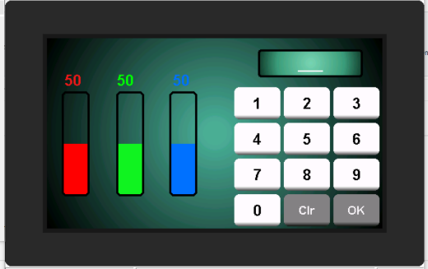
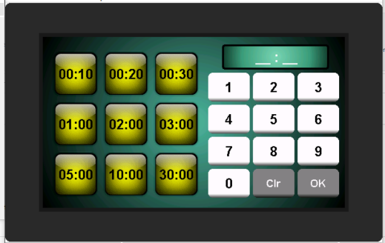
Exposure mode
Settings
Colour and intensity
Timer
Start exposure

Quick Start Instructions
- Check that the correct filter is inserted.
- Select the wells of the 96well plate to be exposed under "MODE".
- Set the light colour and light intensity after unlocking the display bars.
- Set the timer.
- Insert the plate to be exposed.
- Start exposure by pressing and holding the START button for 2 seconds.

Selection of exposure mode
The exposure mode allows for selecting the wells of the 96well plate that shall be exposed.
As long as no mode has been selected “not selected” is shown below the MODE button.
To enter the exposure mode selection menu press the MODE button.

You can choose between 5 preselected modes (every 2nd, 3rd, 4th, 5th well or ALL wells) or you can manually define the wells of the 96well plate that shall be exposed.

Overview of preselections:
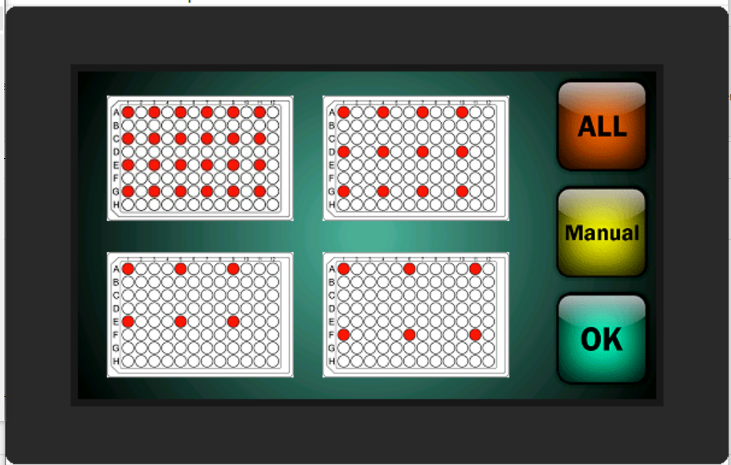

Manual selection:
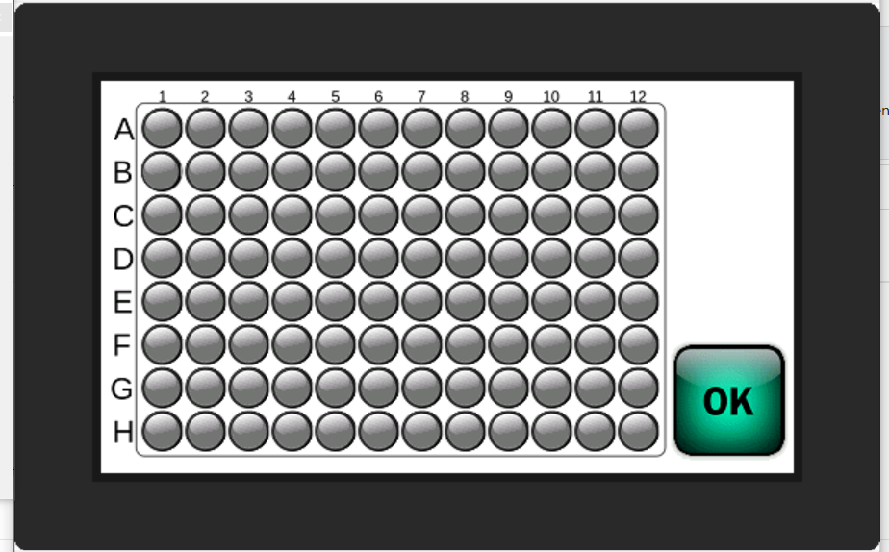

Confirm your choice and leave the exposure mode menu by pressing the OK button.
The selected mode is now shown below the MODE button.

Presetting colour and light intensity
There are intensity columns that show the set intensity of the three different colours both visually as a more or less filled column and as a percentage value on top of the column.
The columns are generally locked (lock sign in the columns).
Touch and hold for 2 seconds on one of the columns to unlock.
Now you can set the new intensity by swiping over the columns.
To avoid accidental changes to intensity settings, the intensity columns are locked again after 10 seconds.

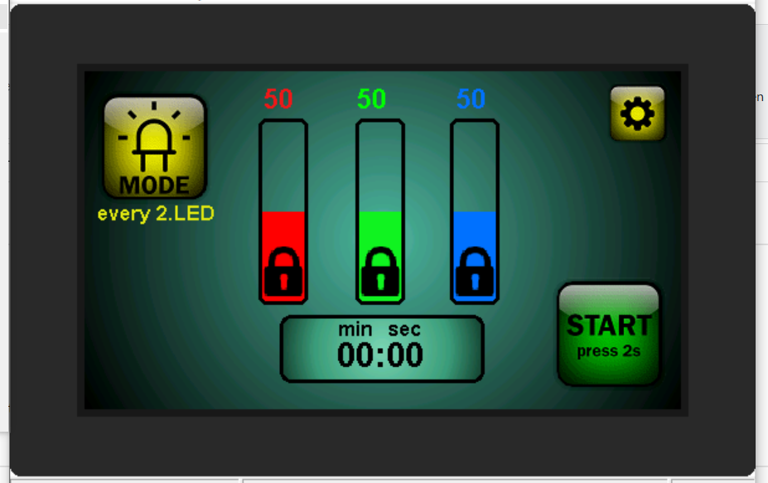

In case you prefer typing in the intensity value instead of swiping, touch the percentage value of the colour you would like to change in the unlocked state to open the input dialogue.

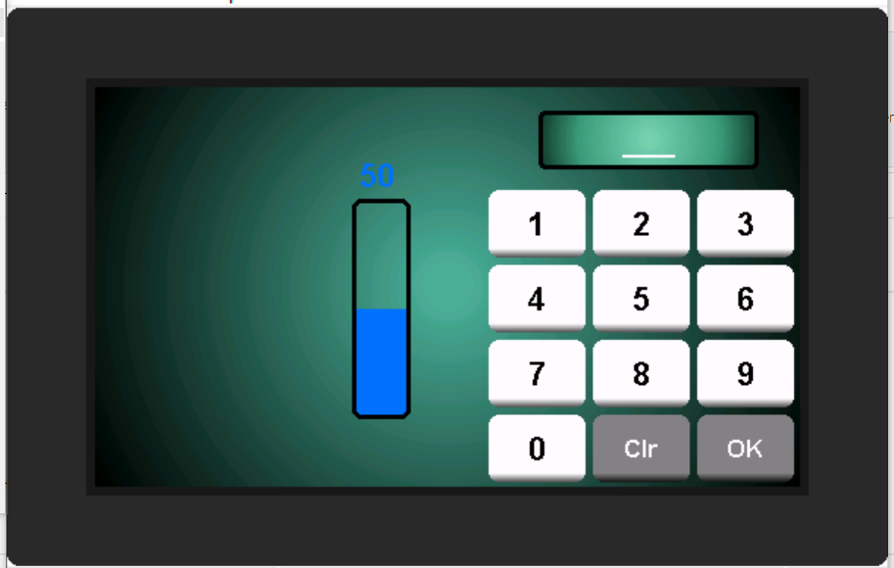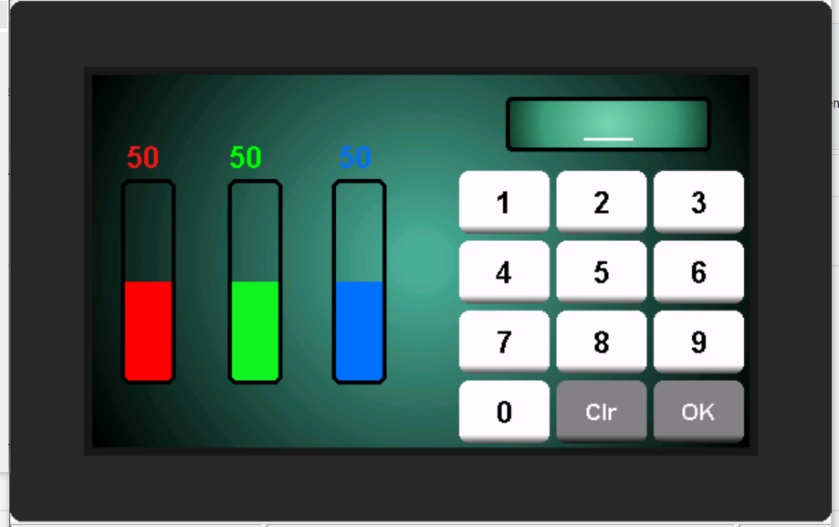

Type in the desired intensity value and confirm the value by pressing OK.
Press OK, again, to return to the main screen.
Or, by selecting one of the other columns, it is now possible to also change the intensity of the other two colours.

Presetting exposure time
To set the timer touch the timer area.

Select a preset timer or type in the required timer countdown and confirm by pressing OK.
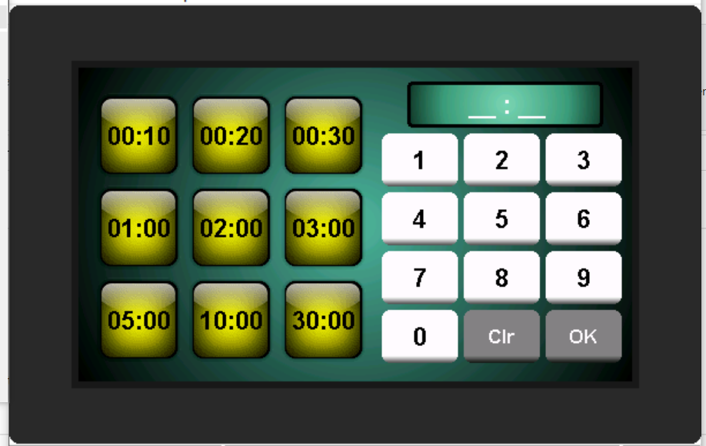

Preset timers can be adapted according to your needs by pressing and holding the timer button you would like to adapt. When the timer is highlighted and shown individually, press clear to delete preset value and type in new time (4 digits).
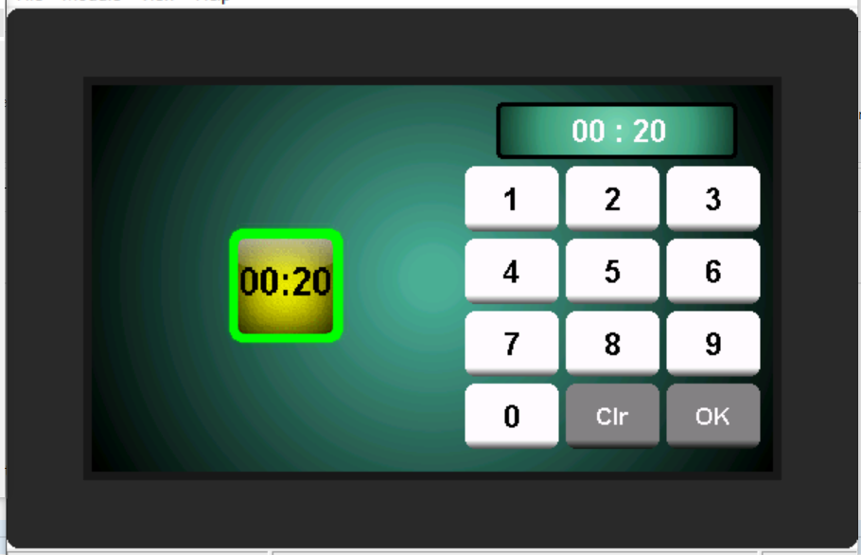

If no exposure time has been selected, a time counter will start when the exposure starts.

Settings
Press the tooth wheel to open “Settings”.

The following can be viewed or set under “Settings”:
• the brightness of the display
• Turn sounds on/off
• Resetting the default preselection timer times (hold for 2 seconds)
• The software version

To exit “Settings” press the OK button.
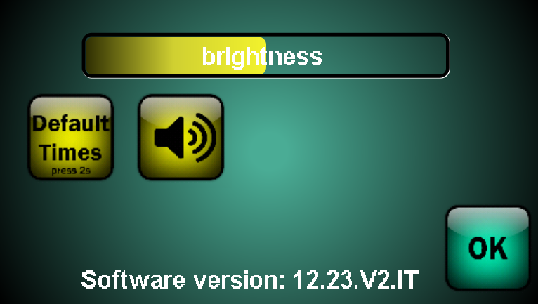

Starting the exposure
After setting mode, intensity and timer press the START button for 2 seconds to start exposure.

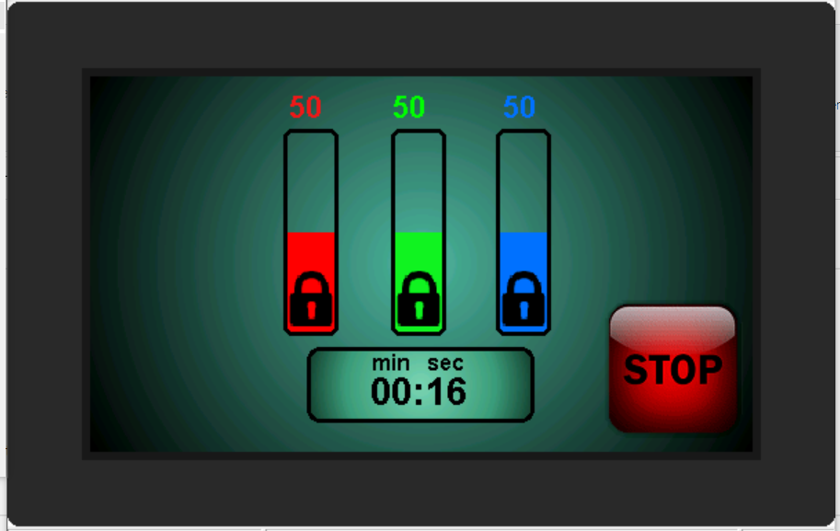

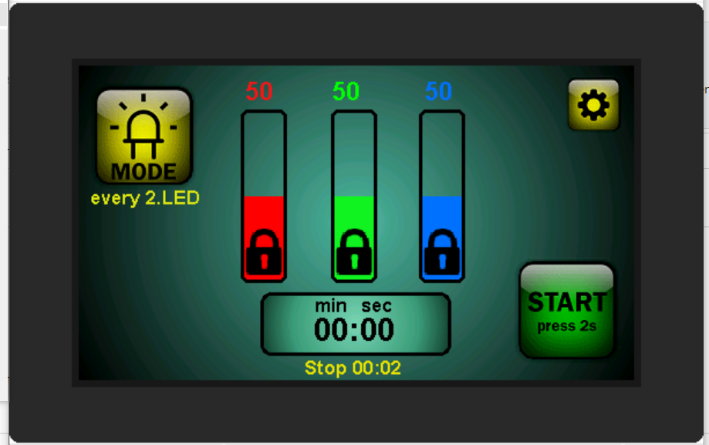

If no exposure time has been selected, a time counter will start when the exposure starts.
When the exposure is stopped manually by pressing the STOP button, the time will be displayed below the timer field. (A copy of what was shown in the timer field at the time of pressing the STOP button is displayed.)
⇒ For a preset timer (countdown) the remaining time is displayed, for a normal counter (no preselected timer) the time of exposure is displayed in yellow characters.

